SPECIAL SEASONAL TOUR

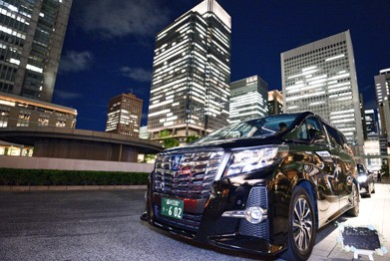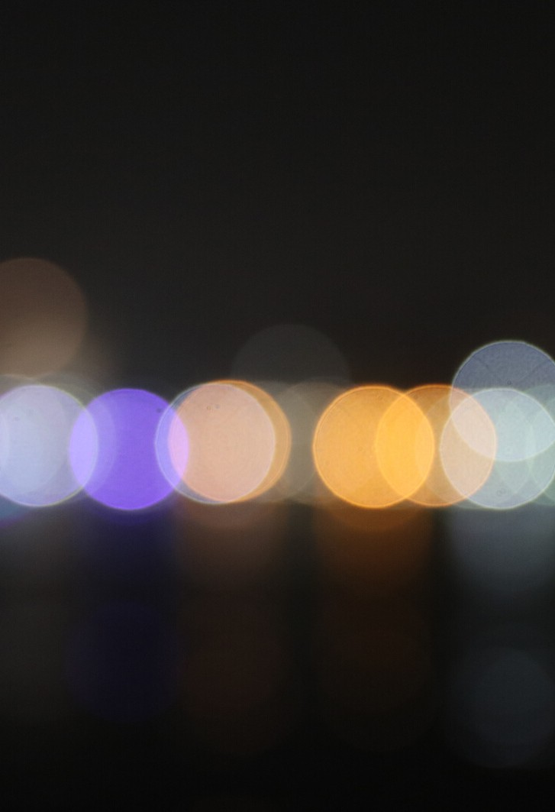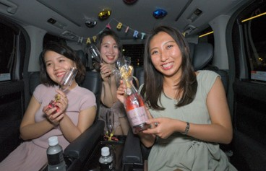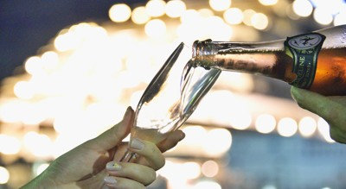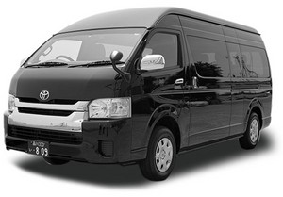

# Night view Tour (3H)

Tokyo central area

↓ Tokyo station

↓ Ginza

↓ Tokyo Tower

↓ Roppongi

↓ Shibuya

↓ Odaiba

↓ Tokyo central

*1 bottle of champagne FREE

*Excludes meal and entrance fee

Hiace (8pax)

2,475 JPY/ PAX

*Includes tolls, parking, tax

*Requestable ENG speaking driver

NOTE:

* PICK UP POINT HANYA DI 23 TITIK:<https://en.wikipedia.org/wiki/Special_wards_of_Tokyo>
* HARGA BELUM TERMASUK TIKET MASUK DAN MAKAN SELAMA TOUR
* TANPA GUIDE, DRIVER ONLY (ENGLISH SPEAKING)
* PERIOD: NOW-END OF SEP 20
* TIDAK PERLU BAYAR TIPPING
* HARGA BERLAKU HANYA UNTUK GRUP 8 PAX